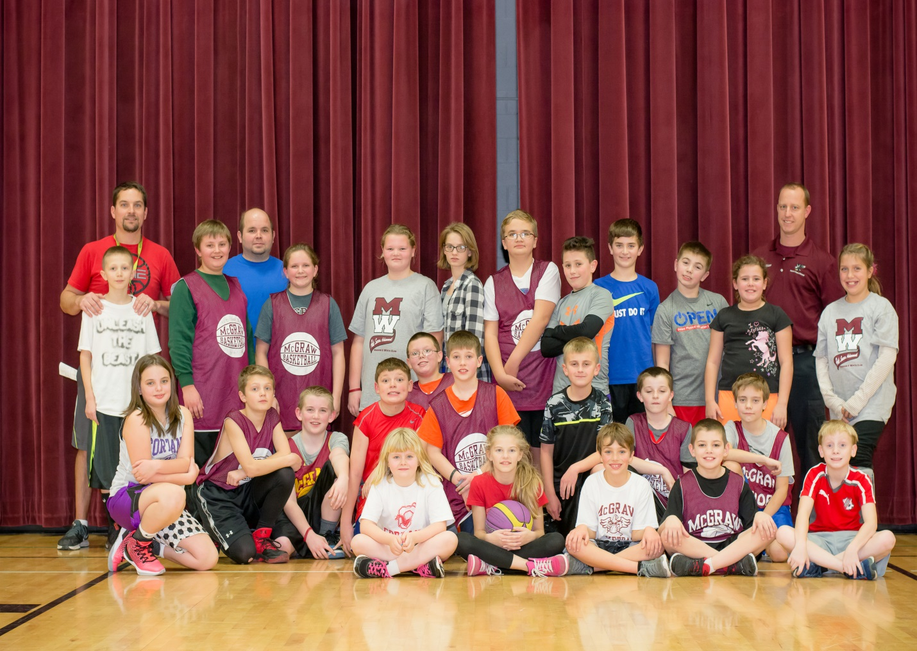
Coaches: Corey Wilson, Ben Doty, Tom McCall and Mike Murray
Managers: Brennan Wilson, Madeline Doty
Players: Dylan Truman, Nicholas West, Gaven Truman, Jacob Bilodeau, Zoey Gaffney, Hailey McCall, Heather Magee, Nicholas Mancini, Noah Heath, Ryan Parks, Kyle Doty, James Hammond, Caleb Epp, Bryce Murray, Daltyn Busby, Blake Bergey, Mariah Thompson, Kendre Euson, Haylee Underwood, Jaydon Bassett, Noah Sargent, Steven Zogg, Gabe Friedman and Hannah Wilson

