6-12 Physical Education 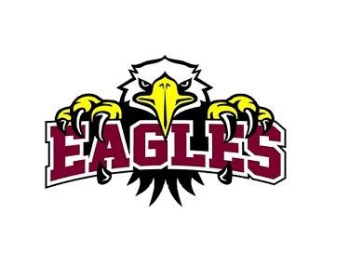Mr.Crumb & Mrs. Hughes

This year will look a little different. But let’s work together and be safe...
- Wearing masks
- Social distancing
- Disinfecting equipment
- Washing/sanitizing hands before entering the gym

Grading Policy
-Every student will be graded everyday:
-Attendance
-Preparedness
-Participation/Skill
-Relations
-A student’s final grade is determined by averaging the 4 criteria, midterm and final test grade.

Attendance Policy
-Students are expected to be present for all classes.
-At end of the marking period, the total number of missed classes equals the final attendance grade.
0 missed classes = 100%, 1 missed = 93%, etc.
-If you miss 7 classes in one marking period you will fail for that quarter.
-It is a student’s own responsibility to make up missed classes (see teacher).

Class Make-ups for Physical Education
-A student who missed class because they skipped may NOT make up that class and will keep their grade of zero for that day.
-Students may NOT make up a P.E. class due to lack of participation or being unprepared during their regular scheduled P.E. class.
-You may only make up a PE class if you were absent due to a medical excuse. Class make-ups will be done online only.

Medical
-A signed note by a doctor must be given to the school nurse prior to class for it to be a legal excuse not to participate.
-Students who are on medical do not need to make up classes, other arrangements will be made.

Be Prepared for Class
-WE WILL NOT BE CHANGING FOR THIS SCHOOL YEAR AND ALL LOCKER ROOMS WILL NOT BE USED.
- New grading policy for being prepared…
- MASKS are REQUIRED!
- SNEAKERS are a MUST! -Appropriate footwear does not include sandals, flip flops, boots or slip-on shoes and if worn will not be allowed to participate due to safety.
- NO dresses. skirts, volleyball shorts, tank tops, etc.
- If you are unprepared 10 classes within a marking period you will fail for that quarter.

We will be outside as much as possible!
- Please bring extra clothes, socks, shoes, pants etc.
- Please bring sweatshirts/jackets according to weather (this includes rain/snow gear)
- Look at the weather ahead of time, so you know how to dress appropriately.
- Periods 1-5: A HEADS UP… the grass will still be wet. Please make sure you bring extra socks and shoes. Also, know that with the ground being wet, you may slip very easily (THIS IS OUR WARNING TO YOU!)
- Personal water bottles are strongly encouraged

Cell Phones
- Leave cell phones in your hallway lockers. Backpacks left in the gym will not be secured.
- There will be a box in the closet to leave your phone if you can’t leave it in your locker. We will give you one warning to put the phone in the box.
- Refusal will be sent to the office.

Equipment Policy
- Before and after use of equipment you will be required to disinfect the used equipment.
- any equipment broken, due to misuse, will be replaced by that student within the school year time frame.

Remote Learning
- Everyone must sign into their google classroom by Sept 11, 2020
- If we go remote, please check into your google classroom during your regular PE period for google meets.
- Check google classroom daily.
- Please turn assignments in on time, all late assignments will not be accepted!!!!!

