Schooltool – Parent Portal Quick Reference Guide

Student Services

The Schooltool Parent Portal can be accessed from any web browser. There is a link on the school’s main web page, or the following url can be typed in the address bar:

https://mcgraw.schooltool.cnyric.org/schooltoolweb/
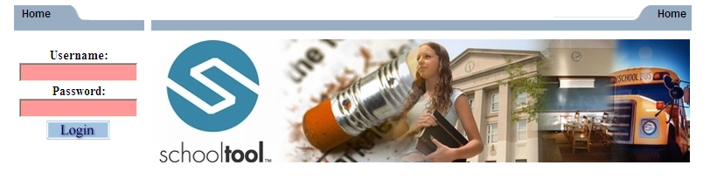

Once the login screen is displayed, use the username and password provided by the district and click Login.

Students Tab:

- Displays all children attached to the parent/guardian. A parent may have the right to click on a student's select button , to see the student's details.

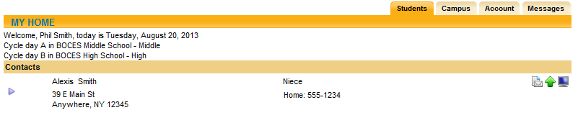

Student’s Details: Displays all student data

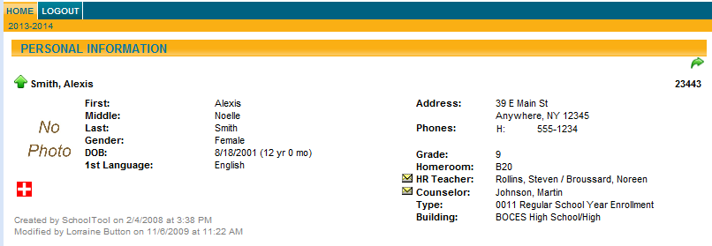
Contact Tab:

- Displays all contacts that have been added for your student
- Displays contact(s) relationship to the student
- Displays contact(s) address
- Displays contact telephone numbers
- Displays enrolled siblings

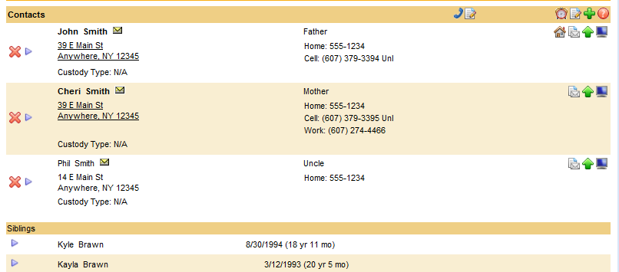

Schedule Tab:

- Displays the student schedule
- Email a teacher by clicking on the envelope icon by the teacher’s name. You may also email all of your student’s teachers together by clicking on the icon next to the word “Teacher” in the header (as shown below)
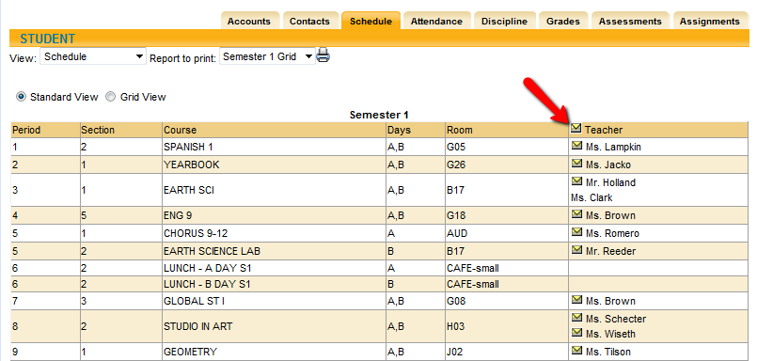

Attendance Tab:

- Displays a summary of the student’s total absences for the current year (if any). This may also include early dismissals and late arrivals.
- Users may change between Daily or Course attendance views by selecting the appropriate radio button.

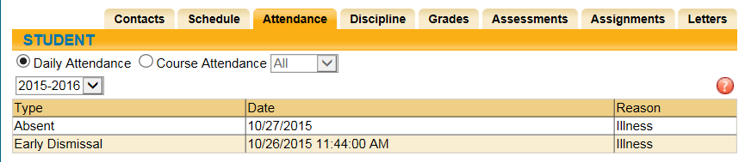

Grades Tab:

- Displays marking period grades
- If you wish to view a different Marking Period, choose it from the dropdown
Marking Period list
- Email a teacher by clicking on the envelope icon by the teacher’s name

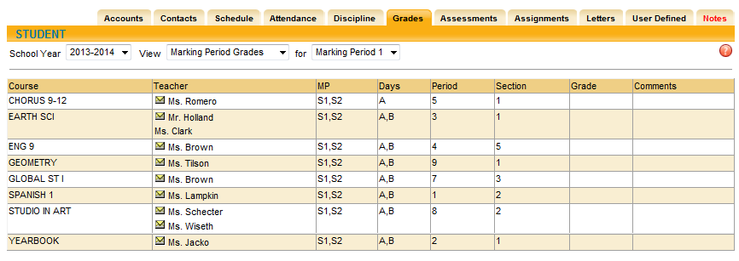

Assessments Tab:

- Displays a student’s 3-8 Assessment scores and any User Defined Assessments

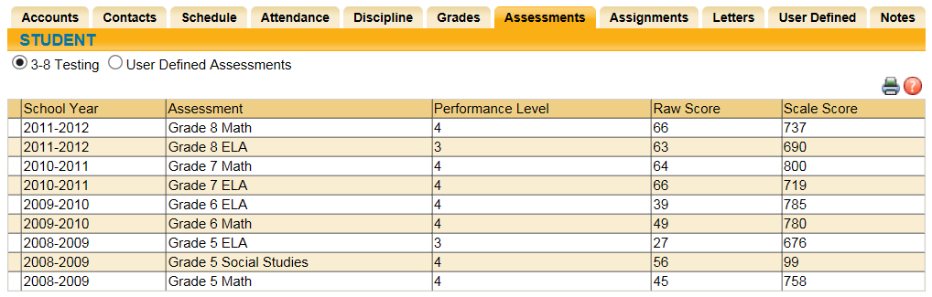

Assignments Tab:

- For middle and high school students, displays assignments for all teachers who
use the Schooltool grade book
- Sort the assignments by clicking on the column titles; Course Name, Assignment
Name, Assignment Date, Max Points or Teacher Name
- Filter the assignments by choosing the dropdown from the Courses list

